Scalable Medicare Claims Fraud Detection Using SQL-Based Feature Engineering and Machine Learning
Zayed M. Uddin¹, Ulugbek Abdurakhmonov², Abu Bakar Siddik Mishkat³, Sarika Rajeev⁴

¹Department of Mathematics and Computer Science, School of Arts & Sciences, CSU—Coppin State University, Baltimore, MD 21216, USA; Email: zayed.md.uddin273@gmail.com
²Department of Mathematics and Computer Science, School of Arts & Sciences, CSU—Coppin State University, Baltimore, MD 21216, USA; Email: ulugbekabdurakhmonov.tennis@gmail.com
³Department of Mathematics and Computer Science, School of Arts & Sciences, CSU—Coppin State University, Baltimore, MD 21216, USA; Email: mishkatfamily@gmail.com
⁴Department of Mathematics and Computer Science, School of Arts & Sciences, CSU—Coppin State University, Baltimore, MD 21216, USA; Email: srajeev@coppin.edu

Everything yellow - things that I think need to be summarized or somehow shortened.
Green - means its really easy to understand and shows what we did and how well we did, which means its good!

1. Abstract
Healthcare fraud in large public insurance programs such as Medicare leads to substantial financial losses and undermines trust in the health system. Detecting fraud at scale is challenging because claims data are high-dimensional, heterogeneous, and highly imbalanced, with confirmed fraud representing only a small fraction of all activity. This paper presents an end-to-end fraud analytics pipeline on a Medicare-like claims dataset that integrates SQL-based feature engineering, unsupervised pattern discovery on fraud-only claims, supervised provider-level classification, and clustering of high-risk providers into fraud-type groups.
We first construct a relational feature store in PostgreSQL that ingests raw inpatient, outpatient, beneficiary, and provider tables, performs systematic cleaning and typing, and produces reusable claim- and provider-level feature tables. These include temporal aggregates of claims and reimbursement, counts of unique beneficiaries, peer-normalized reimbursement and length-of-stay z-scores, and interpretable rule-based indicators for duplicate billing, potential upcoding, and overcharging. Using these features, we perform exploratory analysis to understand distributions, outliers, and correlations, and select a compact set of provider-level variables for modelling.
At the claim level, we restrict attention to claims submitted by labeled fraudulent providers and apply the HDBSCAN clustering algorithm to standardized inpatient and outpatient fraud-only features. Principal component analysis visualizations and association rule mining on diagnosis–procedure combinations reveal heterogeneous clusters of fraudulent claims, including high-payment long-stay inpatient episodes and high-volume outpatient patterns with repeated code combinations and overcharge flags.
At the provider level, we train and compare several supervised models to predict fraud status, including logistic regression with elastic-net regularization, tree ensembles, gradient boosting methods, CatBoost, and a multilayer perceptron. On a stratified 30% hold-out set of labeled providers, all models achieve high ROC-AUC (≈0.93), and a well-regularized logistic regression model achieves the best balance of precision and recall, with a PR-AUC around 0.71 and an F1-score in the mid-0.60s after threshold tuning. We apply this model to unlabeled test providers to obtain fraud risk scores, then form a high-risk provider universe by combining labeled fraudulent providers with high-scoring test providers. HDBSCAN clustering on standardized provider features identifies several fraud-type clusters—such as high-revenue inpatient overchargers, moderate-volume inpatient outliers, and high-volume outpatient overbillers—alongside a diffuse noise set.
Overall, the proposed pipeline shows that a combination of carefully engineered features, interpretable linear models, and targeted unsupervised analyses can deliver competitive provider-level fraud detection performance while also producing actionable fraud-type characterizations that may support human investigation and policy decisions.

2. Introduction
2.1 Background and motivation
Healthcare fraud, waste, and abuse divert scarce resources away from patient care and impose substantial financial losses on health systems worldwide. Estimates for public programs such as Medicare and Medicaid run into billions of dollars annually, driven by practices such as phantom billing, upcoding, unnecessary services, and abuse of reimbursement rules [3], [9], [17], [20]. Beyond direct financial impact, fraudulent claims undermine trust in payers and providers and complicate policy efforts aimed at improving access and quality of care [9], [17].
Modern claims databases—covering millions of encounters across beneficiaries, providers, diagnoses, and procedures—offer an opportunity to detect fraud more systematically but also pose serious analytical challenges. The data are high-dimensional, heterogeneous, and highly imbalanced, with confirmed fraud representing only a small fraction of all claims [3], [9]. Simple rule-based systems, while interpretable and easy to deploy, struggle to keep pace with evolving fraud schemes and can generate many false positives. This has motivated extensive research on machine learning and data mining methods for healthcare fraud detection, spanning supervised classification, unsupervised anomaly detection, and hybrid approaches [3], [5] [9], [14], [20].
2.2 Related Work
Recent surveys document a wide range of machine learning techniques applied to medical insurance and Medicare fraud detection [3], [9], [17], [20]. Supervised models such as logistic regression, decision trees, random forests, support vector machines, and gradient boosting have been trained on labelled provider or claim data to distinguish fraudulent from legitimate behavior, often using Medicare or similar large-scale claims datasets [3], [5], [8], [13], [16], [18]. These methods tend to perform well when sufficient labelled examples exist and when fraud patterns are relatively stable, but they depend heavily on the availability and quality of labelled fraud cases and can struggle to detect emerging or previously unseen schemes [3], [9], [14].
Unsupervised learning offers an alternative route that does not rely on detailed fraud labels. Clustering and outlier-detection algorithms—including k-means, Local Outlier Factor, k-nearest neighbors, Isolation Forest, DBSCAN, and related density-based methods—have been explored for detecting anomalous claims or providers that deviate from typical patterns [1], [2], [6], [10], [15], [19]. In healthcare datasets where labelled fraud is scarce or incomplete, these methods can highlight suspicious cases for further investigation, but they often depend critically on good feature engineering and may yield high false positive rates if used in isolation [1], [2], [6], [19].
A complementary line of work uses association rule mining to discover frequent patterns in claims data and then focuses on rules that appear abnormal or cost intensive [5], [12], [18]. In these approaches, rules are typically filtered by support, confidence, and lift, and then examined as potential indicators of fraud when they involve unusual code combinations or high aggregate costs [5], [12]. This rule-centric perspective helps capture structured fraud schemes that span multiple claims and actors, but it is often studied separately from provider-level risk scoring.
More recent overviews emphasize that healthcare fraud detection in practice increasingly combines multiple paradigms—rules, supervised models, and unsupervised anomaly detectors—to balance adaptability, interpretability, and operational cost [3], [9], [14], [20]. Nevertheless, many published systems focus on either claim-level anomaly detection or provider-level classification in isolation, provide limited detail on end-to-end data engineering pipelines, or give only high-level descriptions of how unsupervised patterns relate back to concrete fraud types [3], [9], [14]. There remains a need for studies that tie together robust feature engineering, interpretable rule-based indicators, unsupervised clustering of fraud patterns, and supervised provider risk scoring within a single reproducible framework.
This paper addresses these gaps by developing and evaluating an integrated fraud detection pipeline on a Medicare-like claims dataset with labelled provider fraud flags. Building on prior work in association rule mining, anomaly detection, and supervised classification for healthcare fraud, our contributions are threefold.
First, we construct a SQL-based feature store that ingests raw inpatient, outpatient, beneficiary, and provider tables; performs systematic cleaning and typing; and produces reusable claim-level and provider-level feature tables. These tables include not only standard utilization and payment variables but also peer-normalized z-scores and interpretable rule-based indicators for potential duplicates, upcoding, and overcharging.
Second, we apply unsupervised clustering specifically to fraud-only claims—those originating from labelled fraudulent providers—to uncover internal structure within fraudulent behavior. Using HDBSCAN on standardized inpatient and outpatient claim features, combined with PCA visualizations and association rule mining on diagnosis–procedure code sets, we identify distinct clusters of fraudulent claims characterized by different code patterns, payment levels, and rule violations. This extends prior rule-mining and anomaly-detection work by explicitly targeting the heterogeneity of fraud rather than treating all flagged claims as a single group [1], [2], [5], [6], [10], [15], [19].
Third, at the provider level, we train and compare several supervised models—including logistic regression with elastic-net regularization, tree ensembles, and a neural network—to predict provider fraud status from aggregated features. We evaluate these models under severe class imbalance using precision–recall and ROC metrics, and we show that a well-regularized logistic regression model achieves competitive performance while remaining interpretable. We then apply the resulting risk scores to unlabeled test providers and perform HDBSCAN clustering on a combined set of labelled fraudulent and high-risk test providers, yielding provider “fraud-type” clusters that summarize how different groups of providers deviate from their peers.
Taken together, these components form an end-to-end, reproducible workflow that links data engineering, claim-level fraud pattern discovery, provider-level prediction, and fraud-type characterization. The approach is designed to be transparent and modular, making it easier to adapt to other claims datasets and to integrate with human expert review in operational fraud investigation workflows. - ALL OF THIS IS METHODOLOGY (or a short summary of methodology, which we will go into in detail in the next chapter, so you can skip this part).

3. Methodology
3.1. Data sources and study design
We used the publicly available “Healthcare Provider Fraud Detection Analysis” dataset from Medical Sphere, which was built from Medicare claims. We use a de-identified Medicare claims dataset with separate training and test partitions. Each partition contains four tables with a common schema: a provider table, an inpatient claims table, an outpatient claims table, and a beneficiary table. The provider table lists billing providers and, in the training data only, a PotentialFraud flag, which we recode as a binary label (label_provider_fraud_1_0) indicating whether the provider is suspected of fraud.
Inpatient and outpatient claim tables contain one row per claim, with a unique claim identifier (ClaimID), a beneficiary identifier (BeneID), a provider identifier (Provider), claim start and end dates, reimbursed amount, deductibles, and up to ten diagnosis codes and six procedure codes. The inpatient table additionally includes admission and discharge dates and diagnosis-group fields. The beneficiary table provides demographic and clinical context, including date of birth and death, sex, race, state and county, months of Part A and Part B coverage, and several chronic condition indicators.
We treat the provider as the primary unit of analysis. The main supervised task is to classify providers as fraudulent or non-fraudulent using their aggregated claims history and the PotentialFraud label available in the training provider table. Claims are used as secondary units: we derive claim-level features and rules, and we apply unsupervised clustering on fraud-only claims to better understand patterns within fraudulent behavior.
The training claims cover a fixed historical period, and the test claims share the same schema but lack fraud labels. For supervised learning, we restrict ourselves to labeled training providers and perform a stratified 70/30 split at the provider level, preserving the fraud/non-fraud ratio. The 70% subset is used for model fitting and cross-validation, while the remaining 30% is held out for evaluation. After model selection and threshold tuning on this labeled data, we apply the final provider-level classifier to the unlabeled test providers to generate fraud risk scores and predicted fraud labels, which are then used in downstream clustering of high-risk providers.
3.2 Data cleaning and SQL feature store
All data processing was implemented in PostgreSQL using a layered design. Raw CSV files were first loaded into a staging schema, where fields were kept as text and only basic checks were applied to ensure that file structure and column counts matched the expected layout. From there, we created a curated schema in which we cleaned and typed the data. Placeholder strings used in the original files to denote missing values (for example, “NA” and “N/A”) were converted to SQL NULL. Columns were then cast to appropriate types: dates to DATE, monetary and count fields to numeric types, and categorical fields such as gender, race, and chronic condition indicators to integer or boolean types. - Summarize this (too much info on basic stuff)
Within the curated schema we enforced simple integrity constraints. We checked that provider identifiers were unique in the provider table and that beneficiary identifiers were unique in the beneficiary table. We verified that claim identifiers were non-null and unique within inpatient and outpatient tables, and we confirmed that each claim’s beneficiary and provider identifiers existed in the corresponding dimension tables. We also validated date fields and computed lengths of stay for inpatient claims, checking that these were non-negative and fell within plausible ranges. Reimbursement amounts were inspected for negative or extreme values, and basic distribution summaries were produced to detect obvious errors. - Same here, too many details, can make this shorter.
On top of the curated tables, we built a mart schema that serves as the feature store for analysis. A consolidated claims fact table joins inpatient, and outpatient claims to their provider and beneficiary records. From this fact table we derived a claim-level feature table containing engineered variables such as length of stay, counts of diagnosis and procedure codes, rule-based flags for duplicates and overcharging, and peer-normalized z-scores. We also created a provider-level feature table by aggregating claims over 30-, 90-, and 365-day windows to compute counts of claims and unique beneficiaries, total reimbursement, code diversity, inpatient and outpatient volumes, and aggregated rule-based counts. These feature tables, along with a data dictionary describing each variable, form the basis for the exploratory analysis, unsupervised clustering, and supervised models described in the following sections. - Same here, too many unnecessary details, can summarize this and make it shorter. Maybe you can combine all three highlighted paragraphs into one or two.
3.3 Feature engineering and rule-based indicators
We constructed features at both claim and provider levels, and implemented a set of simple, interpretable rules to capture common fraud patterns such as duplicate billing, upcoding, and overcharging. All feature engineering was performed in SQL on top of the feature store described above, and the resulting tables were then exported to Python for modelling.
At the claim level, we derived basic utilization and billing variables from the inpatient and outpatient tables. For each claim we computed reimbursed amount, deductible amount, and, for inpatient claims, length of stay from admission and discharge dates. We counted the number of diagnosis and procedure codes attached to the claim and created indicators for “exact” and “near” duplicates by comparing claims for the same beneficiary and provider within short time windows, with similar diagnosis–procedure combinations and amounts. We also defined claim-level overcharge flags based on peer-normalized payment z-scores and interquartile-range (IQR) thresholds, marking claims whose reimbursement was unusually high relative to similar claims.
At the provider level, we aggregated claims over multiple time windows (30, 90, and 365 days) to obtain total claims, total reimbursed amount, and counts of unique beneficiaries. We computed code diversity metrics such as the number of distinct diagnosis and procedure codes used in the recent period, as well as separate counts of inpatient and outpatient claims. Peer-normalized z-scores for reimbursement and, for inpatient services, length of stay were calculated by comparing each provider’s distribution to that of similar providers. Rule-based events were also aggregated, giving provider-level counts of exact and near duplicate claims, suspected upcoding events in inpatient and outpatient settings, and claims flagged as potential overcharges. These engineered features and rule indicators formed the input to both the exploratory analysis and the supervised and unsupervised models described later.

3.4 Exploratory analysis and feature selection
After building the SQL feature store, we carried out exploratory analysis and feature selection in Python. Using an ORM tool for Python and PostgreSQL connection (SQLAlchemy) and pandas, we loaded the claim- and provider-level feature tables and examined basic distributions. For key continuous variables such as reimbursed amounts, deductibles, and inpatient length of stay, we plotted histograms and boxplots to inspect skewness, long tails, and potential data errors. This confirmed the expected heavy-tailed pattern in claim amounts and lengths of stay.
We quantified outliers using simple robust statistics. For each amount-related feature, we computed interquartile ranges (IQR) and flagged claims beyond the conventional “boxplot rule,” as well as robust z-scores based on the median and median absolute deviation (MAD). We then summarized how many claims were flagged as outliers and how those overlapped with rule-based flags such as overcharge indicators or short-stay high-payment inpatient claims.
At the provider level, we examined correlations among the engineered features to reduce redundancy. We calculated pairwise correlation coefficients and variance inflation factors (VIFs) to identify groups of highly collinear variables, for example overlapping measures of recent reimbursement and claim counts across different windows. Based on these diagnostics we retained a compact set of interpretable provider features, including total and recent reimbursement, recent claim counts, unique beneficiary counts, code diversity, peer-normalized z-scores for inpatient and outpatient reimbursement and length of stay, and aggregate counts of duplicate, upcoding, and overcharge events. This reduced feature set was used for all subsequent supervised and clustering analyses. - Summarize and turn this section into two paragraphs.
3.5 Unsupervised fraud-only claim clustering
To better understand heterogeneity within fraudulent behavior at the claim level, we performed unsupervised clustering on fraud-only claims. We first identified fraudulent providers using the training label and then extracted all inpatient and outpatient claims associated with those providers, constructing separate fraud-only claim tables for inpatient (fraud_claims_ip) and outpatient (fraud_claims_op) services. For each claim we used standardized versions of the engineered features, including reimbursed amount, diagnosis and procedure code counts, claim-level rule flags (duplicate and overcharge indicators), and peer-normalized z-scores. Features were imputed where necessary and scaled to zero mean and unit variance before clustering.
We applied the HDBSCAN algorithm to these scaled feature sets for inpatient and outpatient claims separately. HDBSCAN was chosen because it can discover clusters of varying size and density and can label points that do not belong to any stable group as noise. We tuned its main parameters, such as minimum cluster size and minimum samples, and assessed clustering quality using internal validation measures and the fraction of claims labeled as noise. To visualize the resulting structure, we projected the standardized claim features into two dimensions using principal component analysis and plotted the claims colored by their HDBSCAN cluster assignments.
For each claim cluster we computed summary “cluster cards,” describing cluster size, total and median reimbursed amount, typical diagnosis and procedure code multiplicity, and frequencies of duplicate and overcharge flags. We also applied association rule mining within clusters to identify frequent and high-lift combinations of diagnosis and procedure codes. These patterns, together with the cluster summaries, were later used to characterize distinct types of fraudulent claim behavior.
NOT SURE ABOUT THE SECTION ABOVE, IT HAS A LOT OF DETAILS, IDK if you can make that shorter. Maybe try after you made everything else shorter, because I don’t want us to make our project less impressive by cutting out important details.
3.6 Supervised provider fraud classification
Supervised learning was used to predict whether a provider is fraudulent based on aggregated claims features. We restricted modelling to the labeled training providers and performed a stratified 70/30 split at the provider level, preserving the original fraud to non-fraud ratio. All provider-level features described in Section 3.3 were extracted from the feature store and merged with the binary label (label_provider_fraud_1_0). Continuous features were standardized using the mean and standard deviation computed from the training portion only; these transformations were then applied unchanged to the hold-out and test providers.
We compared several classification algorithms implemented using the same feature set for all models. The models included logistic regression with elastic-net regularization, Random Forests, Extremely Randomized Trees, gradient boosting methods (LightGBM and XGBoost), and CatBoost. Because fraudulent providers were much less frequent than non-fraudulent ones, we used class weighting and imbalance-aware parameters where available (for example, class_weight="balanced" for logistic regression and appropriate positive class weights for tree-based methods).
Hyperparameters for each model were tuned by randomized search with five-fold cross-validation on the 70% training subset. We used area under the precision–recall curve (PR-AUC) as the primary model selection metric, as it is more informative than ROC-AUC when the positive class is rare. For each trained model we then evaluated performance on the 30% hold-out set, computing accuracy, precision, recall, F1-score, PR-AUC, and ROC-AUC. Rather than fixing a probability threshold at 0.5, we traced the precision–recall curve on the hold-out set and selected, for each model, the threshold that maximized F1. Logistic regression with elastic-net regularization and class-balanced weighting emerged as the primary model due to its strong PR-AUC, competitive F1-score, and straightforward interpretability via its coefficients. Tree-based models served as additional baselines and helped confirm that performance gains mainly came from the engineered features rather than from more complex architectures.
SAME GOES FOR THE SECTION above, maybe lets try to keep these two about unsupervised and supervised learning parts, cause there are a lot of details, and if I got it right, I think this is kinda like the key difference between our project and most of the other projects - the fact that we used both supervised and unsupervised learning ( or maybe its one of the unique things, right?) that’s why I was thinking to keep the two sections above. But we can discuss this later tonight.
3.7 Provider fraud-type clustering
In addition to predicting whether a provider is fraudulent, we sought to characterize types of fraudulent behavior among high-risk providers. To do this, we constructed a high-risk provider universe by combining all training providers labeled as fraudulent with test providers whose logistic regression fraud score exceeded a high threshold. This yielded a set of providers that either were known frauds in the training data or were scored as strongly suspicious in the unseen test set. For each of these providers we extracted the same standardized features used in the supervised models, including total reimbursement, claim volumes over different windows, counts of unique beneficiaries, peer-normalized inpatient and outpatient z-scores, and aggregated rule counts for duplicates, upcoding, and overcharging.
We then applied the HDBSCAN clustering algorithm to this high-risk provider set. HDBSCAN was chosen because it can discover clusters of varying size and density without requiring the number of clusters to be specified in advance, and it can label providers that do not belong to any stable group as noise. We used Euclidean distance on standardized features, with a minimum cluster size of 10 providers and a small minimum samples parameter, after confirming that these settings produced several meaningful clusters and a reasonable fraction of noise points. To visualize the structure of the high-risk provider space, we performed principal component analysis on the standardized features and plotted the first two components, coloring providers by HDBSCAN cluster label and marking noise providers in grey.
Finally, we summarized each provider cluster using “cluster cards” that report the number of providers, the mix of labeled versus high-scored test providers, and the medians of key utilization, payment, and rule-based features. These summaries are later used to interpret each cluster as a distinct fraud-type archetype, such as high-revenue inpatient overchargers, high-volume outpatient overbillers, or providers characterized by frequent duplicates and overcharge flags.

4. Results - EVERYTHING THAT’S HIGHLIGHTEd in this section, see if you can summarize, sometimes there is just too much information, hard to read and retain all of it and then also look at the picture, maybe shorter pieces of info.
4.1 Data characteristics and exploratory analysis
The training data contained 40474 inpatient claims, 517737 outpatient claims, 138556 unique beneficiaries and 5410 providers with fraud labels. As expected for Medicare billing data, reimbursement amounts were highly skewed. Most claims had modest payments, while a small fraction carried very high reimbursed amounts. Figure 1 shows the distribution of reimbursed amounts across all claims; a large bulk of claims fall in the low-payment range, with a long right tail and a small number of very expensive claims.
When we separated inpatient and outpatient claims, their distributions differed in both shape and scale. Inpatient claims exhibited higher median payments and a broader spread, while outpatient payments were generally smaller but more numerous. For inpatient claims, length of stay also showed a skewed distribution, with many short stays and a smaller number of extended hospitalizations. Figure 2 compares inpatient and outpatient claims in terms of reimbursed amount and, for inpatient claims, length of stay. These plots confirm that inpatient services are costlier and more variable, while outpatient services drive volume.
To quantify the extremity of high-cost claims, we applied interquartile-range and median absolute deviation rules to payment variables. This identified a relatively small set of claims as potential outliers under standard boxplot or robust z-score thresholds. Rather than removing these observations, we retained them because they are precisely the types of claims that may correspond to fraud, abuse, or atypical clinical circumstances. We also examined missing values after our cleaning procedures and found that key modelling variables, such as reimbursed amount and claim identifiers, had essentially no remaining missingness.
At the provider level, we summarized annual activity metrics including total reimbursement, total claims, and unique beneficiaries. A small subset of providers exhibited unusually high volumes of reimbursement, suggestive of behavior that needs closer inspection. To understand redundancy among provider features, we computed pairwise correlations and examined a clustered correlation heatmap (Figure 3). Several variables were highly correlated, particularly overlapping counts and reimbursement totals over different time windows. Based on this analysis and variance inflation factor calculations, we removed strongly collinear variables and retained a compact set of interpretable features, including recent claim volume, annual reimbursement, unique beneficiary counts, peer-normalized inpatient and outpatient z-scores, and rule-based counts for duplicate and overcharge events. This reduced feature set was used in the subsequent unsupervised and supervised analyses.
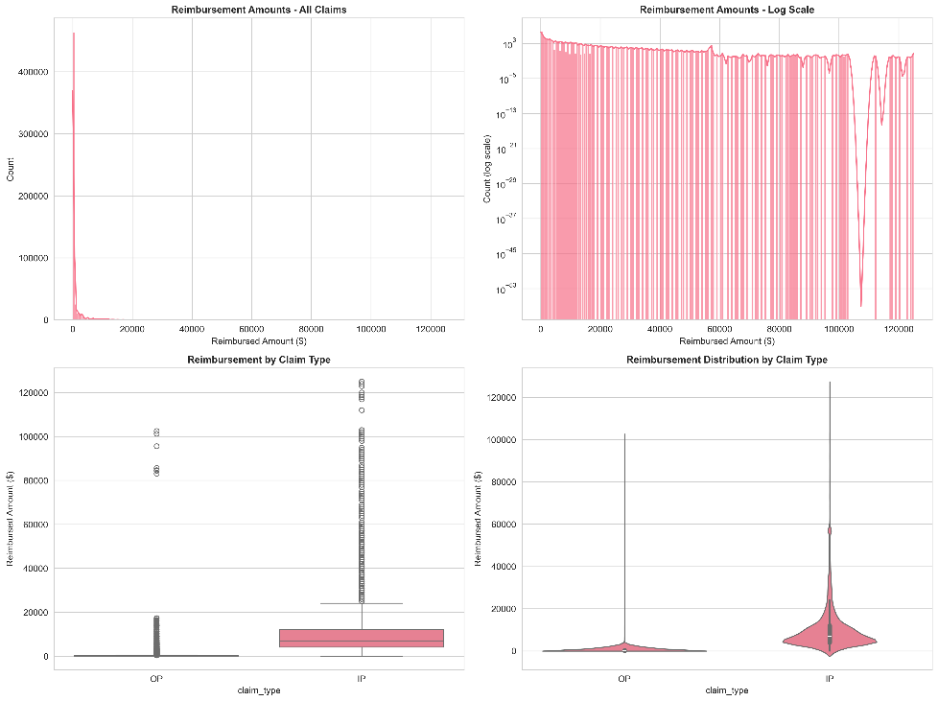
Figure 1. Distribution of claim reimbursements. Histogram and density plots of reimbursed amounts for inpatient and outpatient claims, showing heavy right skew and a small number of very high-cost claims.
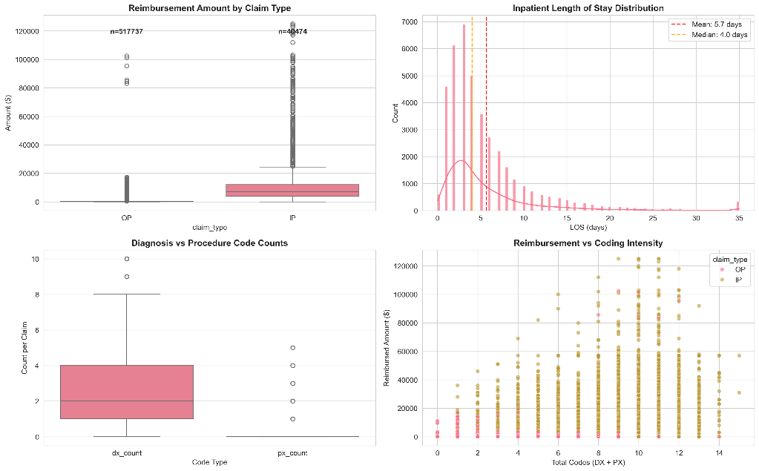
Figure 2. Comparison of inpatient and outpatient claim characteristics. Boxplots of reimbursed amounts and, for inpatient claims, length of stay, highlighting distributional differences between claim types.
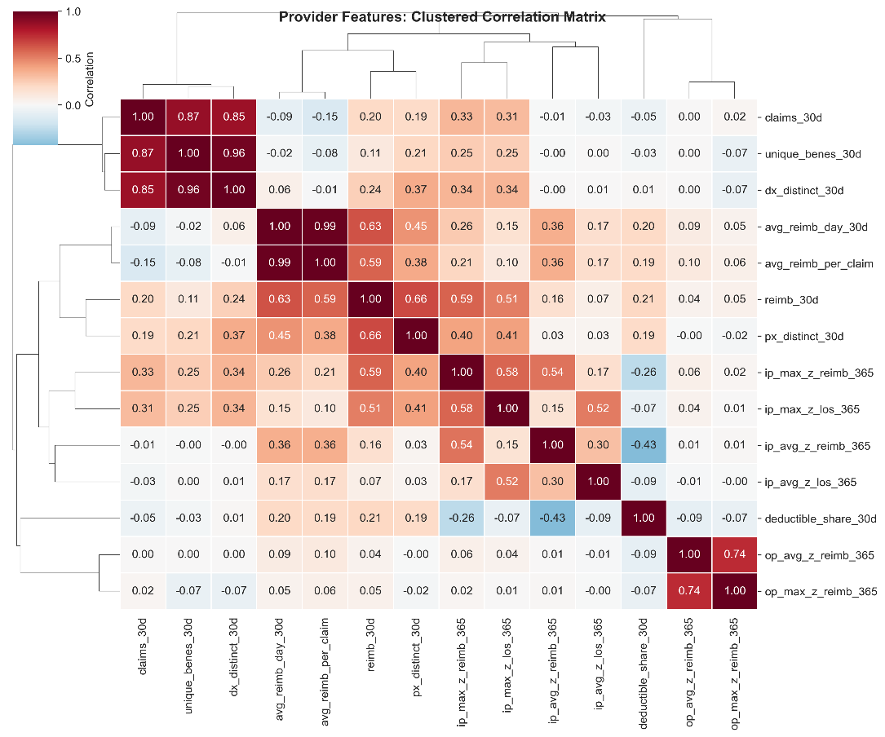
Figure 3. Correlation heatmap of provider-level features. Clustered Pearson correlation matrix for provider features, used to identify highly collinear variables and guide feature selection.

4.2 Unsupervised claim-level patterns among fraudulent claims
To explore heterogeneity within fraudulent behavior, we restricted the claim-level feature table to claims submitted by providers labeled as fraudulent in the training data. This yielded 22640 inpatient and 8408 outpatient fraud-only claims. After standardizing features (amounts, diagnosis/procedure counts, rule flags, and peer-normalized z-scores), we applied the HDBSCAN clustering algorithm separately to the inpatient and outpatient subsets.
For inpatient fraud-only claims, HDBSCAN identified several clusters plus a substantial noise set. The density-based clustering validation index (DBCV) was positive but modest, and approximately one-third of inpatient claims were labeled as noise, indicating that not all fraudulent claims fall into well-defined groups. When we projected the standardized inpatient features into two principal components for visualization, the claims formed a dense band with a few separate groups corresponding to HDBSCAN clusters (Figure 4). Cluster summary statistics showed both fraudulent inpatient stays with moderate lengths of stay and payments, and a smaller cluster of very high-payment, longer-stay admissions with elevated reimbursement and length-of-stay z-scores and occasional overcharge flags.
Outpatient fraud-only claims showed somewhat clearer structure. HDBSCAN again produced several clusters and a noise set, but with a lower noise fraction than in the inpatient case. The PCA projection revealed a large core of relatively homogeneous outpatient fraud claims and a few distinct groups corresponding to high-payment or otherwise atypical claims (Figure 5). Cluster summaries indicated that most outpatient clusters consisted of low- to moderate-paid claims with specific ranges of diagnosis code counts, while one or two clusters captured higher-paid outpatient claims with positive reimbursement z-scores and more frequent overcharge indicators.
To better understand what distinguished these clusters beyond aggregate amounts, we mined association rules on diagnosis and procedure code sets within each cluster. We focused on rules with relatively high support, confidence, and lift, and summarized representative examples in Table 1. For some outpatient clusters, the rules revealed repeated co-occurrence of a small set of diagnosis codes within a cluster that were much less common outside it, consistent with providers repeatedly billing the same limited code combinations. In inpatient clusters, rules highlighted characteristic diagnosis–procedure pairs that tended to appear together in a subset of high-payment claims. Overall, the combination of HDBSCAN and association rule mining provided a compact way to describe different patterns of fraudulent activity at the claim level, which informed both our understanding of provider behavior and the design of rule-based features used later.
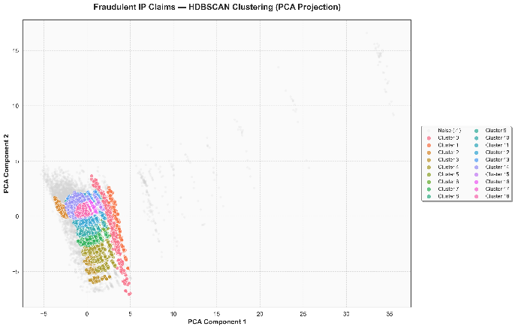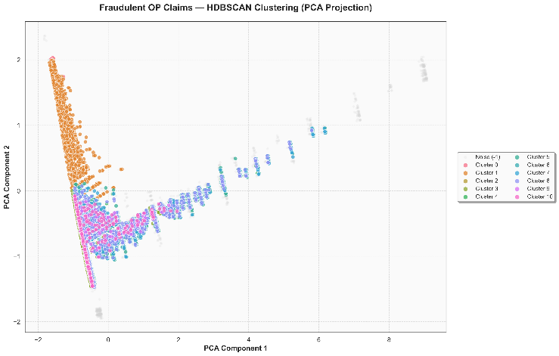
Figure 4–5. HDBSCAN clusters of fraudulent inpatient (left) and outpatient (right) claims. Two-dimensional PCA projections of standardized fraud-only claims are shown, with points colored by HDBSCAN cluster labels and noise points displayed in grey.
Claim Type | Cluster | Antecedents Str | Consequents Str | Support | Confidence | Lift
OP | 1 | 280+285 | 588 | 0.039 | 0.766 | 10.127
OP | 1 | 285+588 | 280 | 0.039 | 0.688 | 9.462
IP | 18 | 995 | 38 | 0.031 | 0.645 | 8.896
OP | 1 | V56 | 588 | 0.024 | 0.637 | 8.425
OP | 1 | 588 | 280 | 0.046 | 0.612 | 8.412
OP | 1 | 280 | 588 | 0.046 | 0.636 | 8.412
IP | 14 | 8154 | 715 | 0.031 | 0.863 | 7.415
IP | 13 | 7935 | 820 | 0.051 | 0.865 | 7.398

Table 1. Example diagnosis/procedure code patterns within claim clusters. Representative association rules for selected inpatient and outpatient HDBSCAN clusters, showing antecedent code sets, consequent codes, support, confidence, and lift, and illustrating recurring code combinations that are concentrated within specific fraud-only clusters.

4.3 Provider-level fraud classification performance
We evaluated several supervised models for predicting provider fraud status using the engineered provider-level features. On the 30% hold-out subset of labeled providers, all models achieved high ROC-AUC (around 0.93–0.94), indicating good discrimination between fraudulent and non-fraudulent providers. Precision–recall performance, which is more informative under class imbalance, varied more across models. A summary of accuracy, precision, recall, F1-score, PR-AUC, and ROC-AUC for each model is given in Table 2.
Logistic regression with elastic-net regularization and class-balanced weighting emerged as the best overall model. Its PR-AUC was approximately 0.71, with ROC-AUC around 0.93, and after threshold tuning it achieved a precision of roughly 0.74 and recall of about 0.56 on the hold-out set, corresponding to an F1-score in the mid-0.60s. Tree-based models such as Random Forests, ExtraTrees, and gradient boosting methods (LightGBM and XGBoost), as well as CatBoost and a shallow multilayer perceptron, achieved similar ROC-AUC values but slightly lower PR-AUC or less favorable precision–recall trade-offs at their best F1 thresholds. In other words, more complex models did not outperform a well-regularized, interpretable linear model on this feature set.
We examined the distribution of logistic regression fraud risk scores across providers (Figure 6). Non-fraudulent providers tended to receive scores near zero, while fraudulent providers showed a broader distribution skewed toward higher scores. The chosen decision threshold separates a small subset of high-risk providers with elevated scores from a large majority with low scores. Among the highest-scoring providers, we observed elevated annual reimbursement, higher claim volumes, higher peer-normalized inpatient or outpatient z-scores, and increased counts of duplicate or overcharge flags, consistent with the design of our features. These risk scores were subsequently applied to the unlabeled test providers to produce fraud risk predictions and were also used to define the high-risk provider universe for clustering in Section 4.4.
Model | Accuracy | Precision | Recall | F1 | PR_AUC | ROC_AUC
LogReg | 0.93 | 0.59 | 0.74 | 0.66 | 0.73 | 0.94
ExtraTrees | 0.91 | 0.53 | 0.74 | 0.61 | 0.70 | 0.93
CatBoost | 0.92 | 0.57 | 0.64 | 0.60 | 0.69 | 0.93
RandomForest | 0.93 | 0.62 | 0.61 | 0.61 | 0.69 | 0.93
LightGBM | 0.91 | 0.51 | 0.78 | 0.61 | 0.68 | 0.93
XGBoost | 0.91 | 0.51 | 0.78 | 0.61 | 0.68 | 0.93

Table 2. Supervised model performance on the provider hold-out set. Classification performance of logistic regression (elastic-net), Random Forests, ExtraTrees, LightGBM, XGBoost, CatBoost, and a multilayer perceptron, reported as accuracy, precision, recall, F1-score, area under the precision–recall curve (PR-AUC), and area under the ROC curve (ROC-AUC).
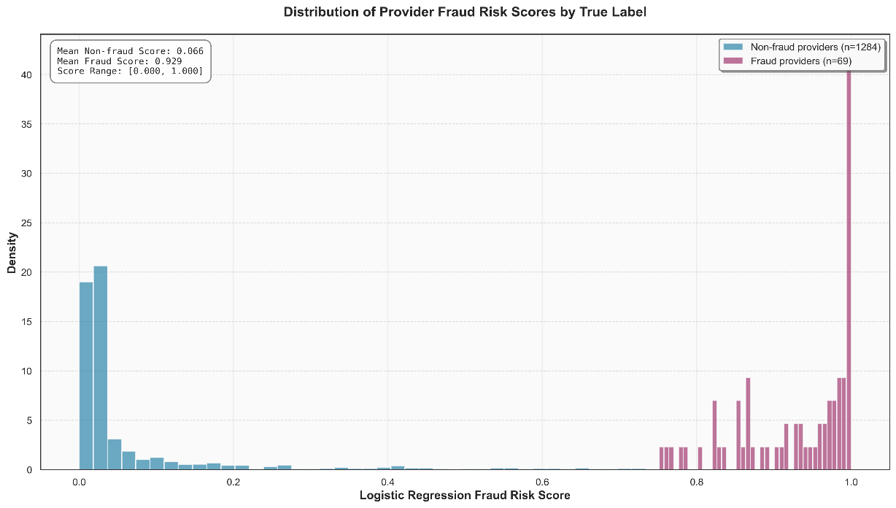
Figure 6. Distribution of provider fraud risk scores. Histogram or density plots of logistic regression fraud risk scores for labeled providers, stratified by true fraud label, illustrating separation between non-fraudulent providers (scores near zero) and fraudulent providers (scores shifted toward higher values).

4.4 Provider fraud-type clusters
To characterize different patterns of fraudulent behavior at the provider level, we constructed a high-risk provider universe consisting of all training providers labeled as fraudulent and test providers whose logistic regression fraud score exceeded a high threshold. This yielded 570 providers in total. Using the standardized provider-level features, we applied HDBSCAN to this high-risk set. The algorithm identified four clusters of providers and labeled the remaining 334 providers as noise, indicating that these providers did not belong to any dense group in feature space.
A two-dimensional PCA projection of the high-risk providers (Figure 7) shows several compact regions corresponding to HDBSCAN clusters, as well as a diffuse cloud of noise points. The largest cluster (Cluster 3, 180 providers) consists of moderate-volume providers with substantial annual reimbursement and inpatient activity, whose maximum inpatient reimbursement and length-of-stay z-scores are elevated but whose duplicate and overcharge counts are relatively modest. A smaller cluster (Cluster 1, 36 providers) comprises high-revenue providers with more extreme inpatient z-scores and evidence of inpatient upcoding, consistent with an “inpatient overcharger” pattern.
Two additional smaller clusters capture more targeted outpatient behaviours. Cluster 0 (10 providers) contains high-volume outpatient billers with multiple duplicate claims and many claims flagged by overcharge rules, indicating a combination of high throughput and suspicious billing. Cluster 2 (10 providers) consists of outpatient-only providers with very large claim volumes, large beneficiary panels, and a high number of overcharge flags, suggestive of systematic small-ticket overbilling. Table 3 summarizes these clusters, reporting, for each, the number of providers, the mix of labeled and high-scored test providers, and median values of key utilization, payment, z-score, and rule-based features. Together, these results show that fraudulent and high-risk providers do not form a single homogeneous group but instead fall into several distinct fraud-type archetypes.
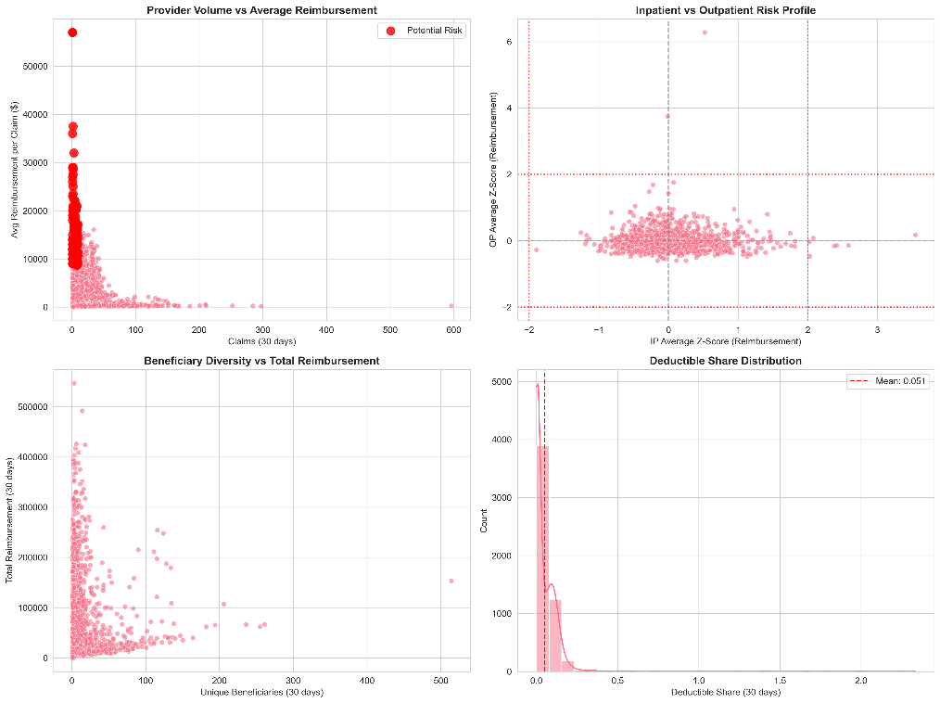
Figure 7. Clusters of high-risk providers. Two-dimensional PCA projection of standardized provider-level features for high-risk providers, colored by HDBSCAN cluster label, with noise providers shown in grey.
cluster | n_providers | n_train_fraud | n_test_highrisk | median_reimb_365d | median_claims_365d
0 | 10 | 10 | 0 | 252570 | 309
1 | 36 | 36 | 0 | 490880 | 140
2 | 10 | 10 | 0 | 390030 | 1336
3 | 180 | 180 | 0 | 210265 | 108

Table 3. Summary of provider fraud-type clusters. For each provider cluster identified by HDBSCAN, the table reports the number of providers, the fraction originating from labeled training frauds versus high-scored test providers, and median values of key features such as annual reimbursement, claim volume, peer-normalized z-scores, and counts of duplicate, upcoding, and overcharge flags.

5. Discussion/Conclusion
This work developed an end-to-end fraud analytics pipeline on Medicare-like claims data that ties together SQL-based feature engineering, unsupervised pattern discovery on fraud-only claims, supervised provider-level classification, and clustering of high-risk providers into fraud-type groups. Conceptually, it sits in the space mapped out by recent surveys and position papers that call for integrated, multi-paradigm approaches to healthcare fraud detection, rather than single model point solutions [3], [9], [14], [17], [20].
(I think the main purpose of our research project was to build a system that can identify fraudulent insurance providers, but this next sentence sounds like we were researching how well certain algorithms can do compared to others? If that’s also a part of our research then keep it, but if not, then I don’t think that paragraph fits.)
On the supervised side, we found that a relatively simple logistic regression model with elastic-net regularization and class-balanced weighting performed competitively with more complex tree-based and neural models. All models achieved high ROC-AUC on the hold-out provider set, but logistic regression offered a favorable precision–recall trade-off and a PR-AUC around 0.71, while remaining easy to interpret through its coefficients and calibrated risk scores. This aligns with systematic reviews showing that “classical” models (logistic regression, tree ensembles, SVMs) remain strong baselines for healthcare claims fraud when paired with good feature engineering [3], [9], [13], [20], even as optimized deep learning approaches are starting to appear in the literature [8], [16]. Our results reinforce the idea that, in tabular insurance data, carefully designed temporal aggregates, peer-normalized statistics, and rule-based counts can be at least as important as model complexity. - I MIGHT BE BIASED but i don’t like this paragraph at all. It doesn’t really fit with the rest of the project.
Unsupervised and anomaly-detection methods played a complementary role. We applied HDBSCAN to fraud-only inpatient and outpatient claims, then used PCA visualizations and association rule mining on diagnosis–procedure combinations to uncover heterogeneity within fraudulent behavior. This is consistent with a broader trend toward unsupervised or weakly supervised methods for fraud and anomaly detection in health insurance, including clustering and density-based methods [1], [6], [15], [19], explainable unsupervised anomaly detection [2], and multivariate outlier models such as WMTDBC [15]. Our approach is particularly close in spirit to Hamid et al., who combines association rule mining with unsupervised classifiers on CMS claims to highlight suspicious patterns [5], and to sequence- and pattern-based methods that use frequent subsequences or trajectories to capture complex schemes [12]. Rather than directly labeling claims from these unsupervised models, we use them to describe and differentiate fraud-only clusters, which then inform both interpretation and rule design.
At the provider level, clustering the high-risk provider universe—combining labeled fraudulent providers with unlabeled providers that received high fraud scores—yielded several distinct fraud-type clusters and a large noise set. This echoes earlier work that uses clustering or multistage unsupervised approaches to identify outlier providers or utilization profiles in administrative data [10], [15], [19]. In our case, cluster summaries suggested intuitive provider archetypes, such as high-revenue inpatient overchargers, moderate-volume inpatient outliers, high-volume outpatient billers with many duplicate or overcharge flags, and outpatient-only providers with very large claim volumes. Such typologies complement global risk scores and are similar in spirit to recent “explainable anomaly detection” approaches that seek to group and characterize anomalies rather than simply rank them [2].
The pipeline design itself—built around a SQL feature store with explicit staging, curated, and mart layers—aligns with work advocating for closer integration between data warehousing, SQL-based analytics, and machine learning in fraud detection [11]. By pushing much of the aggregation, normalization, and rule logic into the database, we obtain a transparent and reproducible feature space that can be reused across multiple models and analyses. This is compatible with emerging architectures for real-time or near–real-time analytics that combine data warehouses with cloud-native processing engines [7] and could in principle be combined with blockchain-based or graph-based infrastructures proposed for secure, auditable fraud detection in health insurance [4], [10], [14].
Several limitations of our study are important. First, the PotentialFraud label is only a proxy for true fraud status and may reflect partial investigations, automated rules, or historical heuristics, an issue frequently raised in reviews of healthcare fraud data mining [3], [9], [17]. Label noise and incomplete coverage of fraudulent providers can bias both supervised models and the fraud-only subsets used for unsupervised clustering. Second, our analysis is limited to a single Medicare-like dataset in a fixed time window. We did not evaluate temporal drift or generalization to other payer types or national systems, whereas prior studies emphasize the importance of context and local coding practices (for example, in Nigerian health insurance [18]) and call for cross-system validation [14], [17]. Third, our pipeline operates in batch mode; we did not implement real-time scoring, streaming ingestion, or online monitoring for concept drift, which are key elements of “next generation” operational systems [7], [14]. Fourth, while we borrow ideas from deep learning and sequence mining work [8], [12], [16], we did not explore graph-based, sequence-based, or end-to-end deep models that might capture provider–patient networks or temporal dependencies more richly. Finally, we lacked access to domain experts to manually review specific claims and providers, so our fraud-type clusters should be interpreted as indicative patterns rather than validated typologies.
These limitations suggest clear directions for future work. One avenue is to embed the current feature store and models into a real-time analytics stack, incorporating streaming data, low-latency scoring, and dashboards for monitoring model calibration, performance drift, and feature drift, in line with recent work on cloud-native analytics [7] and “next-generation” fraud systems [14]. Another is to integrate more advanced unsupervised and explainable methods—such as the explainable anomaly detection frameworks proposed for insurance data [2] and unsupervised multivariate models like WMTDBC [15]—directly into provider- and claim-level scorecards. A third direction is to explore richer model classes, including optimized deep learning architectures [8], [16] and sequence models [12], especially when longer longitudinal claim histories are available. Finally, applying the pipeline to additional datasets and settings (for example, different insurers or national contexts [18]) and involving subject-matter experts in reviewing representative cases from each fraud-type cluster would strengthen both the empirical evidence and the practical interpretability of the approach.
In conclusion, our study shows that a modular pipeline combining a SQL-based feature store, interpretable rule-based indicators, unsupervised pattern discovery on fraud-only claims, and supervised provider risk scoring can deliver competitive predictive performance while also yielding interpretable fraud-type clusters. Rather than competing with more specialized approaches—such as deep learning models [8], [16] or sophisticated unsupervised frameworks [1], [2], [15], [19]—our contribution is to demonstrate how these ideas can be orchestrated within a transparent, reproducible workflow that is compatible with the broader trends and challenges identified in recent surveys and position papers on healthcare fraud detection [3], [9], [14], [17], [20].
I might be getting this wrong but after reading the conclusion, it sounds like our main goal was to compare how well certain models can do with identifying fraud in insurance providers.
In the beginning of the paper, I don’t really see that clearly, like this whole until I read the conclusion, I was thinking that we were researching the healthcare system/insurance companies to see how many of them are fraudulent and building this system that can identify that.
But now it seems different. I’m not sure, I might just be getting it mixed up, but we should talk about it later. I will go read the into again, but in any case we need to somehow make our goal clear at the beginning so the conclusion and intro are connected.

I double checked and this first paragraph:
Healthcare fraud in large public insurance programs such as Medicare leads to substantial financial losses and undermines trust in the health system. Detecting fraud at scale is challenging because claims data are high-dimensional, heterogeneous, and highly imbalanced, with confirmed fraud representing only a small fraction of all activity. This paper presents an end-to-end fraud analytics pipeline on a Medicare-like claims dataset that integrates SQL-based feature engineering, unsupervised pattern discovery on fraud-only claims, supervised provider-level classification, and clustering of high-risk providers into fraud-type groups.
-> Makes it sound like: Problem (Healthcare fraud) -> our solution (we built this system that identifies fraud), but the conclusion sounds like: Problem(We don’t know which models are better for working with messy datasets like medicare) -> Solution: our systems we tried buncha methods and models and figured out that these models are better than those… and etc… you get what I mean?

6. References
[1] M. Bairy, B. Muniyal, and N. P. Shetty, “Enhancing healthcare data integrity: Fraud detection using unsupervised learning techniques,” Int. J. Comput. Appl., vol. 46, no. 11, pp. 1006–1019, 2024, doi: 10.1080/1206212X.2024.2408262.
[2] H. De Meulemeester, F. De Smet, J. van Dorst, E. Derroitte, and B. De Moor, “Explainable unsupervised anomaly detection for healthcare insurance data,” BMC Med. Inform. Decis. Mak., vol. 25, art. 14, 2025, doi: 10.1186/s12911-024-02823-6.
[3] A. du Preez, S. Bhattacharya, P. Beling, and E. Bowen, “Fraud detection in healthcare claims using machine learning: A systematic review,” Artif. Intell. Med., vol. 160, art. 103061, 2025, doi: 10.1016/j.artmed.2024.103061.
[4] G. Saldamli et al., “Health care insurance fraud detection using blockchain,” in Proc. 7th Int. Conf. Softw. Defined Syst. (SDS), 2020, pp. 145–152, doi: 10.1109/SDS49854.2020.9143900.
[5] Z. Hamid, F. Khalique, S. Mahmood, A. Daud, A. Bukhari, and B. Alshemaimri, “Healthcare insurance fraud detection using data mining,” BMC Med. Inform. Decis. Mak., vol. 24, art. 112, 2024, doi: 10.1186/s12911-024-02512-4.
[6] Kanksha, A. Bhaskar, S. Pande, R. Malik, and A. Khamparia, “An intelligent unsupervised technique for fraud detection in health care systems,” Intell. Decis. Technol., vol. 15, no. 1, pp. 127–139, Feb. 2021, doi: 10.3233/IDT-200052.
[7] D. P. Katasani, “Real-time analytics: Integrating cloud-native data processing and warehousing platforms,” J. Comput. Sci. Technol. Stud., vol. 7, no. 9, pp. 516–524, 2025, doi: 10.32996/jcsts.2025.7.9.59.
[8] P. A. Kumar and S. Sountharrajan, “Insurance claims estimation and fraud detection with optimized deep learning techniques,” Sci. Rep., vol. 15, art. 27296, 2025, doi: 10.1038/s41598-025-12848-0.
[9] N. Kumaraswamy, M. K. Markey, T. Ekin, J. C. Barner, and K. Rascati, “Healthcare fraud data mining methods: A look back and look ahead,” Perspect. Health Inf. Manag., vol. 19, no. 1, p. 1i, 2022. Available: https://perspectives.ahima.org/
[10] Q. Liu and M. A. Vasarhelyi, “Healthcare fraud detection: A survey and a clustering model incorporating geo-location information,” in Proc. 29th World Continuous Auditing and Reporting Symp. (WCARS), Brisbane, Australia, Nov. 21–22, 2013.
[11] R. Maddali, “Machine learning for SQL-based anomaly detection and fraud analytics in financial data,” Int. J. Res. Leading Publ., vol. 2, no. 10, pp. 1–11, Oct. 2021. Available: https://www.ijlrp.com/
[12] I. Matloob, S. A. Khan, and H. U. Rahman, “Sequence mining and prediction-based healthcare fraud detection methodology,” IEEE Access, vol. 8, pp. 143256–143273, 2020, doi: 10.1109/ACCESS.2020.3013962.
[13] E. Nabrawi and A. Alanazi, “Fraud detection in healthcare insurance claims using machine learning,” Risks, vol. 11, no. 9, art. 160, 2023, doi: 10.3390/risks11090160.
[14] K. Razzaq and M. Shah, “Next-generation machine learning in healthcare fraud detection: Current trends, challenges, and future research directions,” Information, vol. 16, no. 9, art. 730, 2025, doi: 10.3390/info16090730.
[15] L. Settipalli and G. R. Gangadharan, “WMTDBC: An unsupervised multivariate analysis model for fraud detection in health insurance claims,” Expert Syst. Appl., vol. 215, art. 119259, 2023, doi: 10.1016/j.eswa.2022.119259.
[16] P. S. Shungube, T. Bokaba, P. Ndayizigamiye, S. Mhlongo, and E. Dogo, “A deep learning approach for healthcare insurance fraud detection,” Research Square preprint, Dec. 2024, doi: 10.21203/rs.3.rs-5453482/v1.
[17] A. Y. B. R. Thaifur, M. A. Maidin, A. I. Sidin, and A. Razak, “How to detect healthcare fraud? A systematic review,” Gac. Sanit., vol. 35, suppl. 2, pp. 441–449, 2021, doi: 10.1016/j.gaceta.2021.07.022.
[18] T. S. Yange, O. Onyekware, and H. A. Soriyan, “A fraud detection system for health insurance in Nigeria,” J. Health Inform. Afr., vol. 6, no. 2, pp. 64–73, Feb. 2020, doi: 10.12856/JHIA-2019-v6-i2-256.
[19] M. C. Massi, F. Ieva, and E. Lettieri, “Data mining application to healthcare fraud detection: A two-step unsupervised clustering method for outlier detection with administrative databases,” BMC Med. Inform. Decis. Mak., vol. 20, art. 160, 2020, doi: 10.1186/s12911-020-01143-9.
[20] S. S. Waghade and A. M. Karandikar, “A comprehensive study of healthcare fraud detection based on machine learning,” Int. J. Appl. Eng. Res., vol. 13, no. 6, pp. 4175–4178, 2018.

